REPORT OF JUDICIAL COMMITTEE TO
GENERAL SYNOD, TE HĪNOTA WHĀNUI 2018

- The Judicial Committee is established by Title C Canon IV and consists of nine members. There is a requirement for there to be at least two members from each Tikanga and one Bishop, one Ordained Minister and at least three laypersons within the group.
- Bishops, Ordained Ministers, and laypersons enrolled as barristers or solicitors of the High Court of New Zealand and of not less than seven years’ standing or who hold similar qualifications and experience in any of the legal jurisdictions in the Diocese of Polynesia, are eligible for election.
- After election, a Chair and on occasion a Deputy Chair are appointed from amongst the members.
- The primary tasks of the Judicial Committee are set out in Title C Canon IV, section 4, clause 4.1, and involve determination of questions and appeals.

4.1 The Judicial Committee is also tasked with reviewing motions of General Synod/te Hīnota Whānui and Standing Resolutions on a regular basis after each General Synod/te Hīnota Whānui, pursuant to the Title C Canon II, clauses 2 and 3.
- The Judicial Committee does not meet or attend to any business other than when issues are expressly put before it.

The present membership of the Judicial Committee is:

House of Bishops | The Rt Rev’d Victoria Matthews
House of Clergy | The Rev’d Joel Rowse
Tikanga Māori | Judge Stephanie Milroy  Mr David Stone
Tikanga Pākehā | Judge Chris Harding (Chair)  Judge Anne McAloon  Ms Brigit Brant
Tikanga Pasefika | Mr Walton Morgan  Ms Mele Taliai
General Secretary | The Rev’d Michael Hughes

6. Meetings of the Committee

The Committee has not met in person because there has been no substantial business for us to consider. We met by email exchange.

None of the resolutions from General Synod/te Hīnota Whānui 2016 were seen as warranting inclusion as a standing resolution.

Other matters
The Judicial Committee was asked to draft a standing order in relation to social media, but considered that the Synod may have confused standing orders with standing resolutions and that changing standing orders is within the power of Synod generally, subject to the provisions of Standing Order 104 regarding notice and a Committee process within synod for that to happen.

The Committee on Statutes and Canons would ordinarily be the appropriate body to draft an amendment to a Standing Order and to offer it to the Synod/te Hīnota and we considered they should be invited to do that.

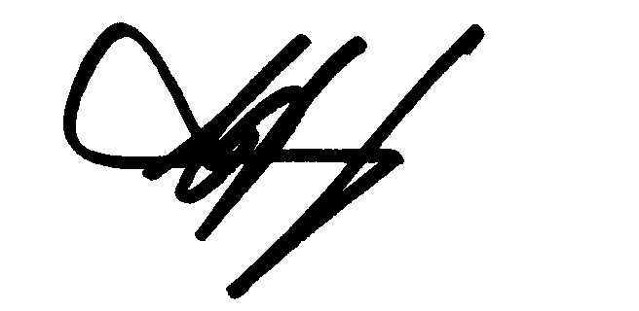

C J Harding

Chair

